RH 134: Chapter 2: Scheduling future task

**Deferred user task:**

User can run command or set a command **at** a set point in future this schedule commands are often call jobs or tasks the term deferred indicate that these task or job going to run in the future.

“**atd**” daemon is installed and enabled automatically to schedule deferred task using at and more other command

To run a job after 5 min from now

[root@rhel82 ~]# date >> /root/date.txt | at now +1min

warning: commands will be executed using /bin/sh

job 4 at Sat Jul 10 07:54:00 2021

To check the job (atq or at –l )

[root@rhel82 ~]# atq

4 Sat Jul 10 07:54:00 2021 a root

[root@rhel82 ~]# at -l

6 Sat Jul 10 08:00:00 2021 a root

To check job in real time

[root@rhel82 ~]# watch atq



To check what command will execute

[root@rhel82 ~]# at -l

7 Sat Jul 10 08:04:00 2021 a root

**8 Sat Jul 10 08:05:00 2021 a root**

**[root@rhel82 ~]# at -c 8 [job number]**

To delete a job

[root@rhel82 ~]# atq

9 Sat Jul 10 08:08:00 2021 a root

[root@rhel82 ~]# atrm 9 [Job number]

How to In put a script file to at command

**Create a script file “myscript.sh” and then write below command**

{Create a script file myscript.sh in /root/myscript.sh write below content

echo “My name is Abdur Rouf” >> myname.txt

save and exit, change “myscrip.sh” file permission #chmod +x myscript }

**[root@rhel82 ~]# at now +2min < myscript.sh**

“Operator “<” is used and input the script to **at** command

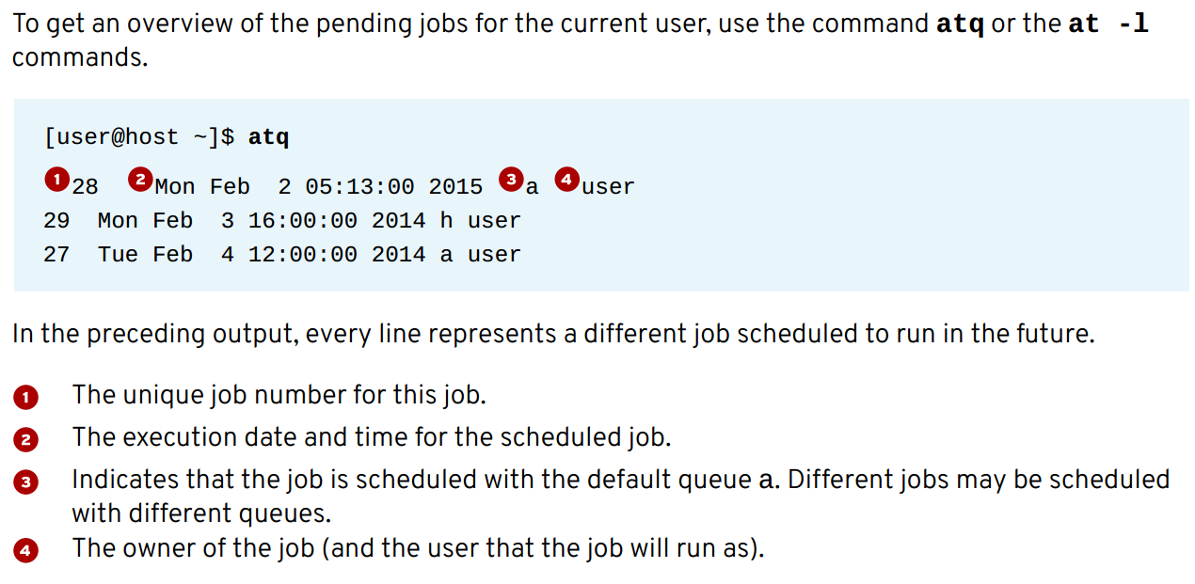

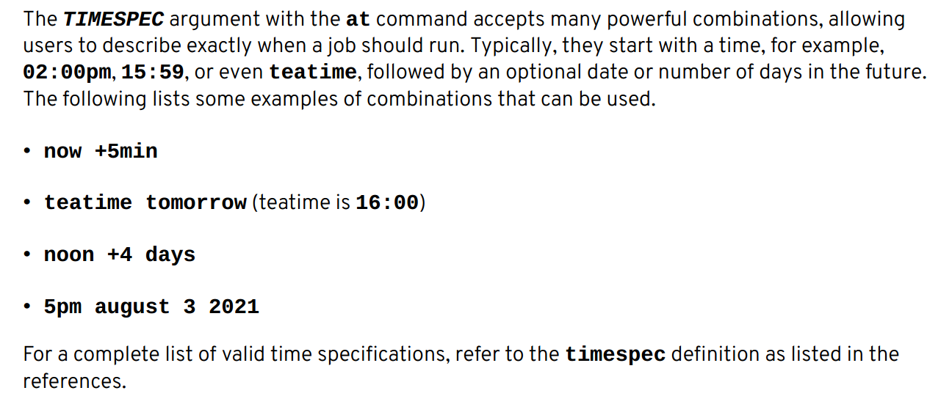

Use at command to interactively schedule another job using queue b

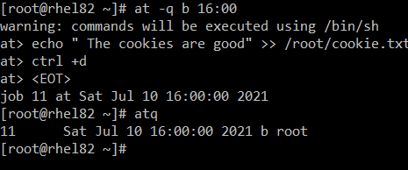

Use at command to interactively schedule another job using queue g

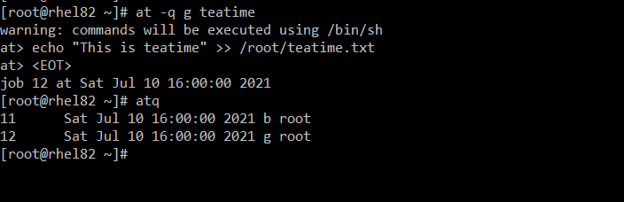

**Section-1:**

**Scheduling recurring user jobs:**

Package name: cronie

Daemon name: crond

The crond daemon read multiple configuration fiels : one per user (Edited with the crontab command) and a set of system wide files. These configuration files give users and administrators fine-grained control over when their recurring jobs should be executed.

Normal users can use ctrontab command to manage their jobs

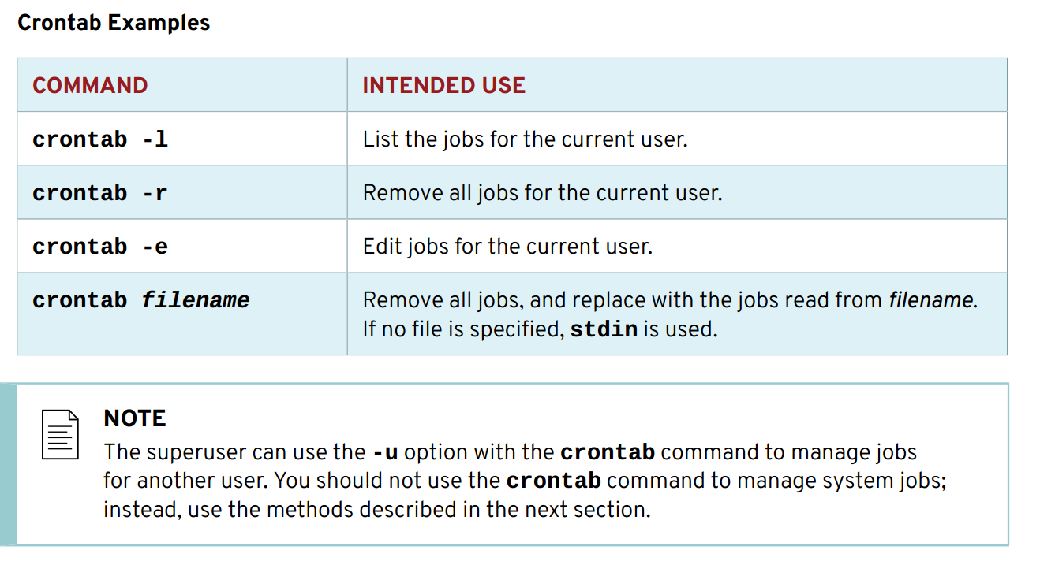

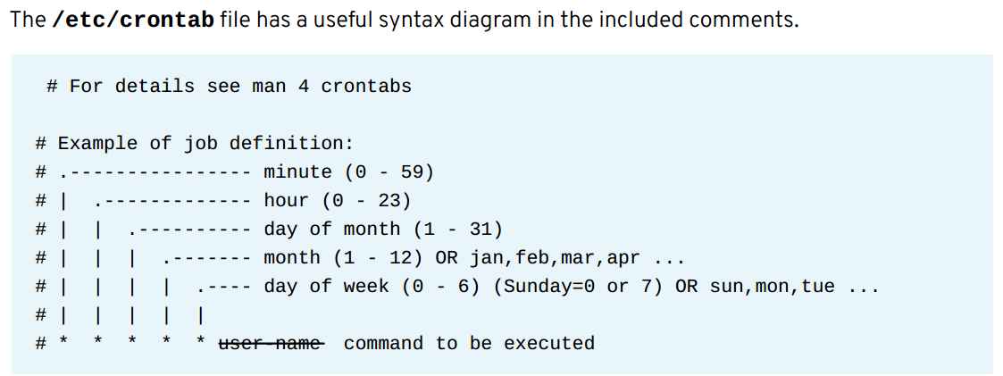

Crontab –e command will open crontab file in editing mode, we can edit to schedule recurring jobs, the syntax of the file as follows:

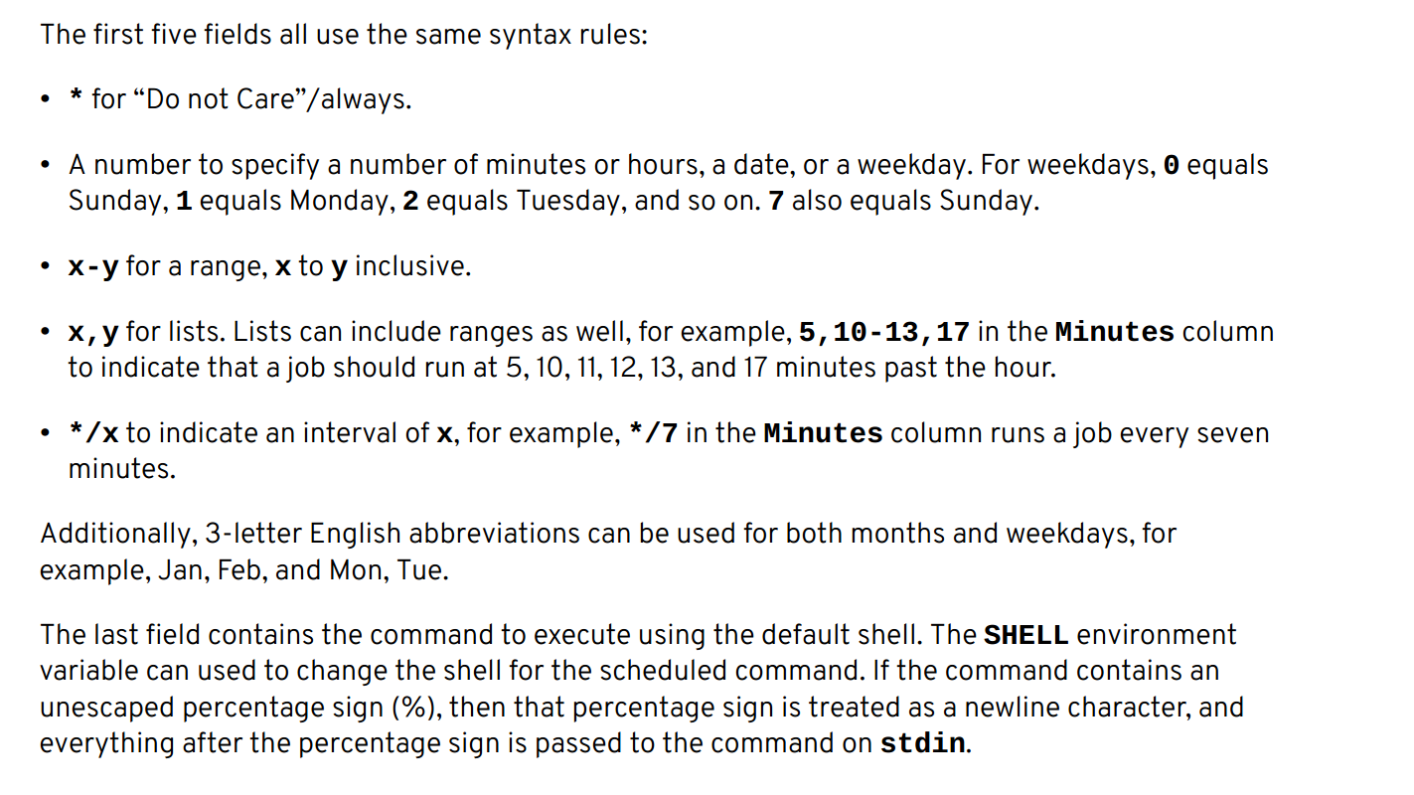

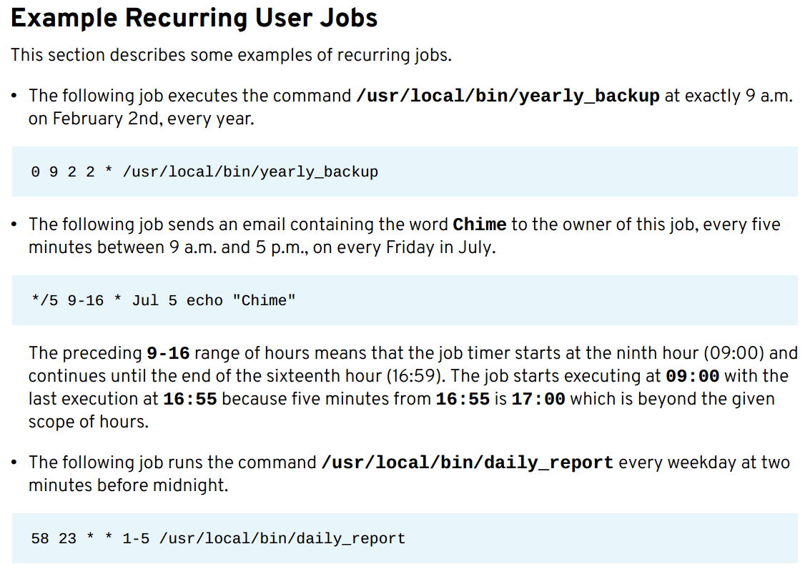

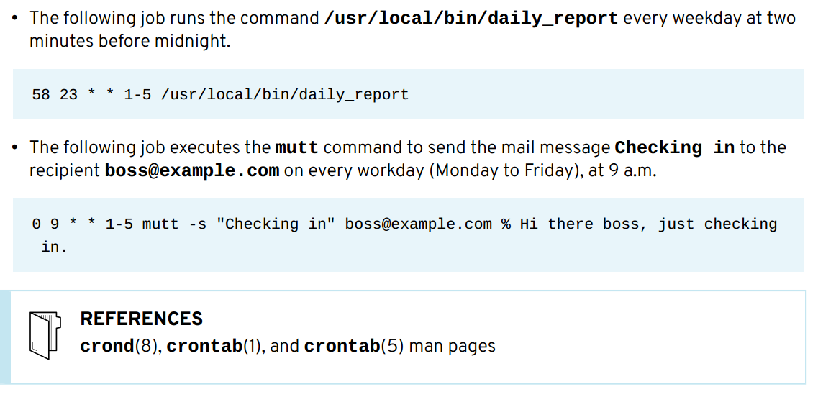

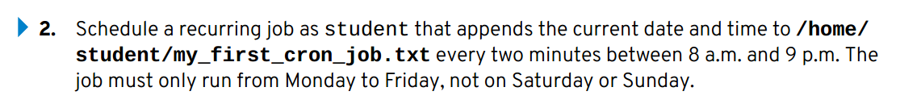

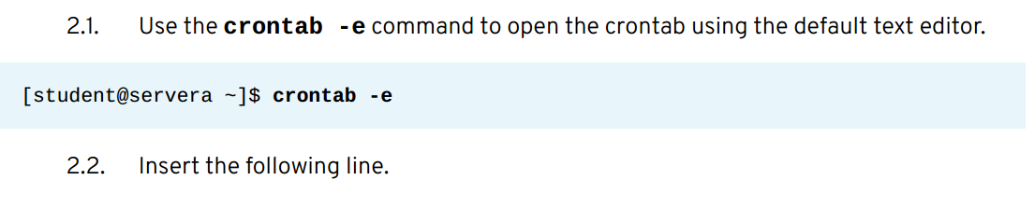

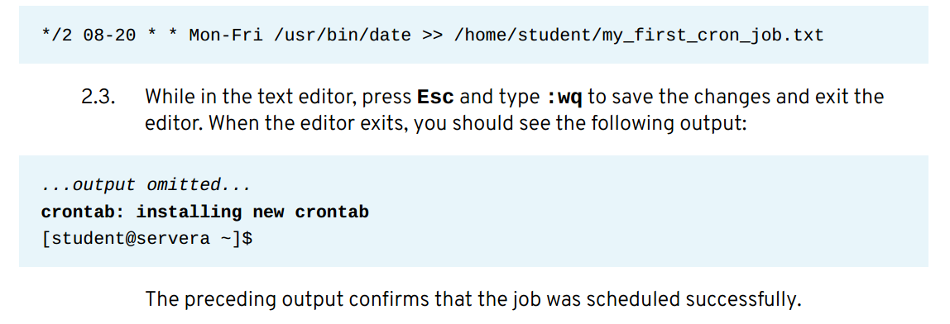

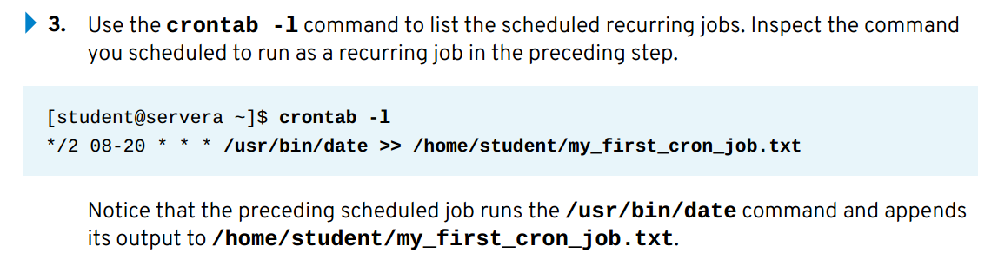

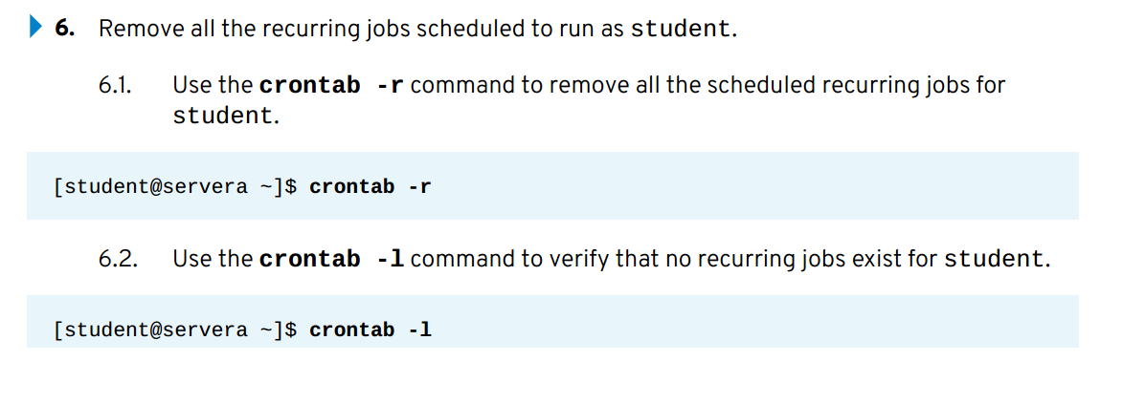

**Section-2:**

**Scheduling recurring system jobs:**

